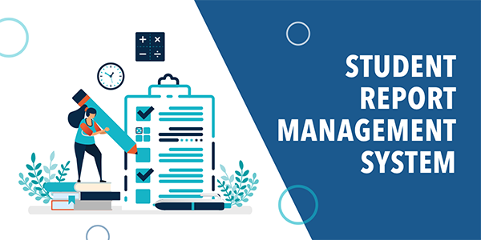

**PROJECT REPORT**

**PROGRAMMED AND PRESENTED BY:**

ANISH BENJWAL(CO20307)

LALIT KUMAR(CO20328)

VYOM VERMA(CO20368)

ACKNOWLEDGEMENT

We would like to express our special thanks to our teacher and mentor **Dr Sarabjeet Singh** as well as our principal who gave us the golden opportunity to do this wonderful project on the topic Student Report Management System, which also helped us in doing a lot of Research and we came to know about so many new things. We are really thankful to them.

**ABSTRACT**

The main aim of our project is to provide an easy-to-use application software which is light on system resources, to store student’s exam record.

The project is intended to protect the environment by reducing paper use to store students exam records and thus preventing cutting of trees and maintaining ecological balance of the nature.

**Table of Contents**

1. INTRODUCTION........................................................................
2. AIM OF PROJECT......................................................................
3. PROJECT MODULES.................................................................
4. COMPILER SPECIFICATIONS.................................................
5. FLOWCHART..............................................................................
6. PROJECT DESCRIPTION..........................................................

6.1 PERSON.................................................................................

6.2 ADMIN...................................................................................

6.3 STANDARD..........................................................................

6.4 TEACHER..............................................................................

6.5 STUDENT..............................................................................

1. SCOPE OF PROJECT..................................................................
2. USER INTERFACE.....................................................................
3. CONCLUSION............................................................................

10. REFERENCES............................................................................

**1.Introduction**

It is a simple program that is easy to use, very light on system resources and very stable. It is a terminal-based program implemented in C++ programming language to manage student’s annual exam record.

**2.Aim of Project**

The main aim of this project is to provide an easy-to-use digital program to record students’ exam performance in primary and secondary schools.

**3.Project Modules**

The project has been divided into many small modules to run efficiently and effectively, easy to understand and debug. Some important modules used in the project are:

* ADMIN MODULE
* TEACHER MODULE

**4.Compiler Specifications**

The program is written in C++ programming language by **Bjarne Stroustrup** compiled with mingw g++ compiler for windows platform and can only be used on windows platform as some of the components used in the program are platform dependent. The hardware requirements of the program are very minimal:

1. Pentium dual core processor
2. 512mb ram
3. Windows vista or later

**5.FLOWCHART**

START

MAIN MENU

ADMIN TEACHER

MENU MENU

EXIT

END

**6.PROJECT DESCRIPTION**

The project is based on the key concepts of object-oriented programming in C++. It consists of a parent class from which all the other classes used in the program are derived implementing the concept of hierarchical inheritance, virtual functions, friend functions, static variables, vectors etc.

The project is divided in five main classes:

6.1 PERSON

6.2 ADMIN

6.3 STANDARD

6.4 TEACHER

6.5 STUDENT

**6.1. PERSON:**

This is the base and an abstract class of the program, most of the classes are derived from this class. It contains all the variables and functions which are common to all the derived classes and thus reducing code repetition and helping us to follow the **DRY**(Do not Repeat Yourself) principle helping us saving time and making the code readability much easier.

**6.2. ADMIN:**

The admin class of the program contains all the root functions of the program which are used to register teachers, create standards and allotting subjects and standards to the teachers, providing the usernames and passwords to the teachers.

**6.3. STANDARD:**

This is also a derived class which contains all the functions and variables required to create a standard. This class also contains the class in charge name, view marks function for the whole standard, subject teachers allotted to the standard etc.

**6.4. TEACHERS:**

This class contains all the data of teachers and member functions which are required to load student’s data from the file, input their marks add students and the menu function required to login by the teacher.

**6.5.STUDENT:**

This class holds all the credentials of the student like roll number, in which standard the student is studying and the marks of the students are also stored with the help of this class.

This project clears various key concepts of object-oriented programming in C++ such as data encapsulation, inheritance, data abstraction use of vectors a standard template library which is a very powerful feature of C++. Comments are used throughout the project so that if any other programmer wants to add new features to the project so it would be lot easier to understand the code.

**7.SCOPE OF THE PROJECT**

There are a lot more features that can be added to the project such as a graphical user interface which will make it much easier to use and improve the user experience. The polished software will look much better but will also consume more system resources which can be minimised with optimisations in the code accordingly. For more security the data encryption can be applied on the whole code. For now, these features where beyond the scope of the project as limited basic C++ is to be used to make this project.

**8.USER INTERFACE**

8.1 Main Menu:

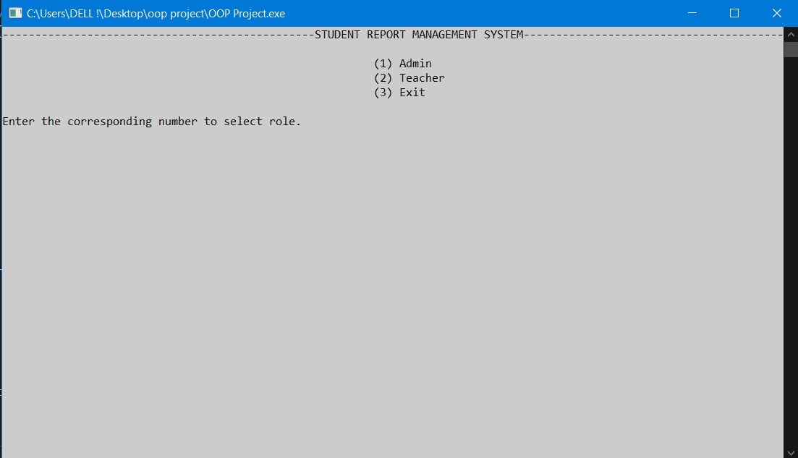

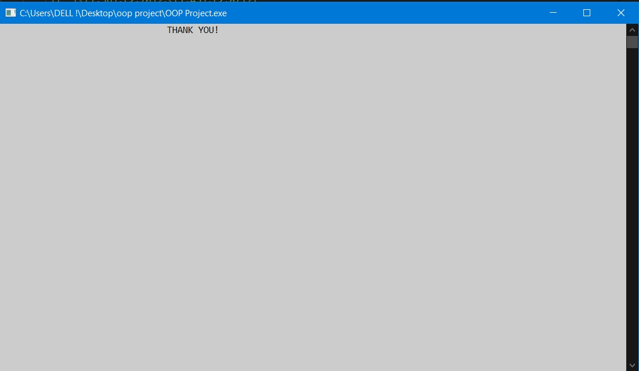

8.2 Admin Menu :

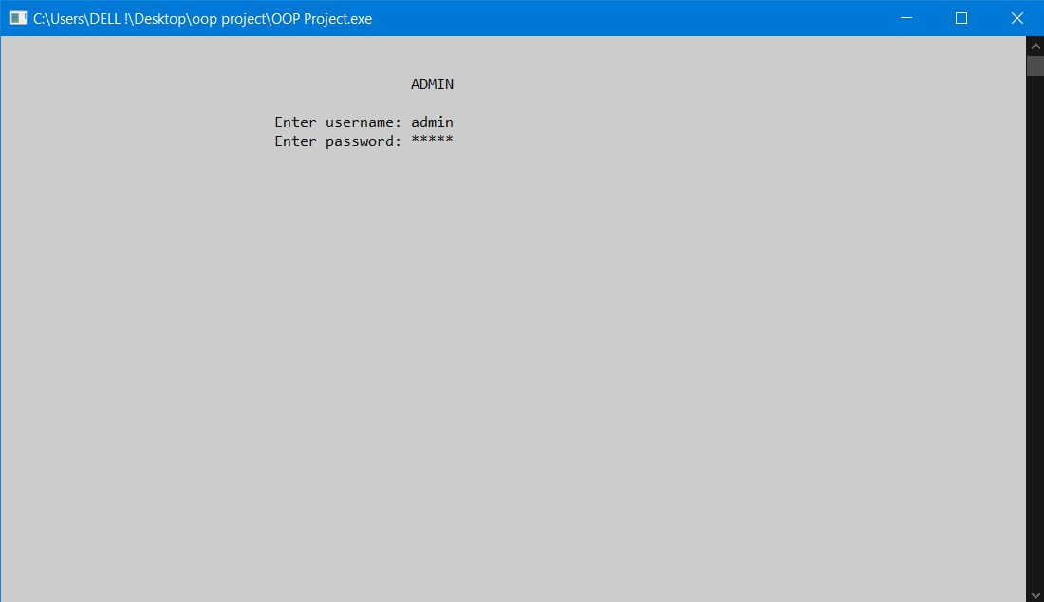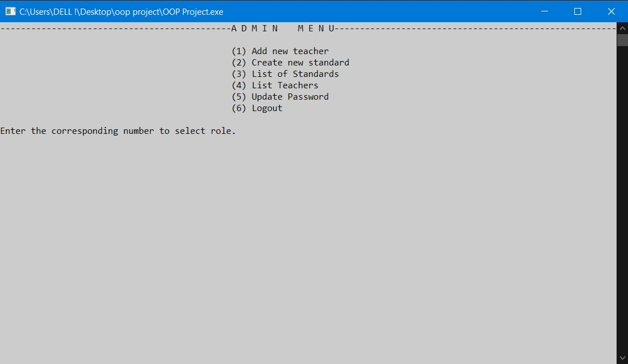

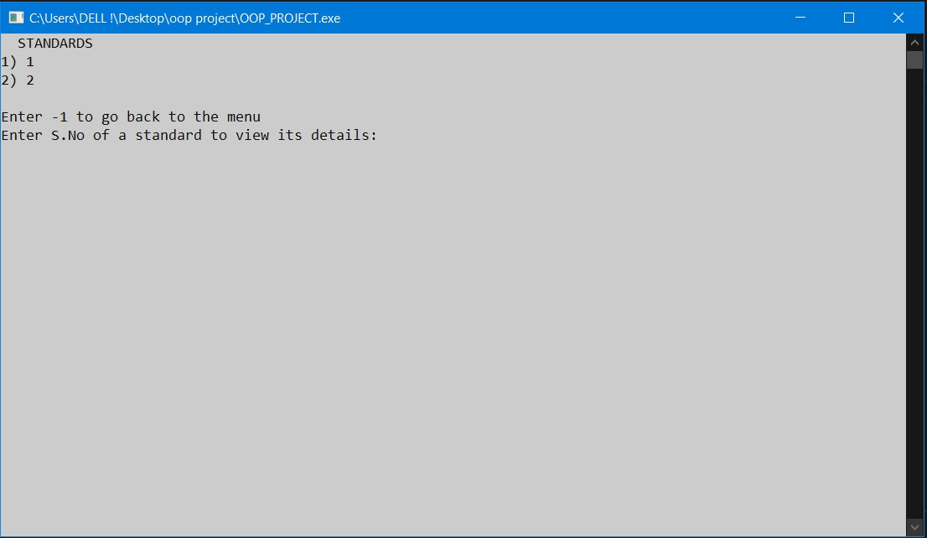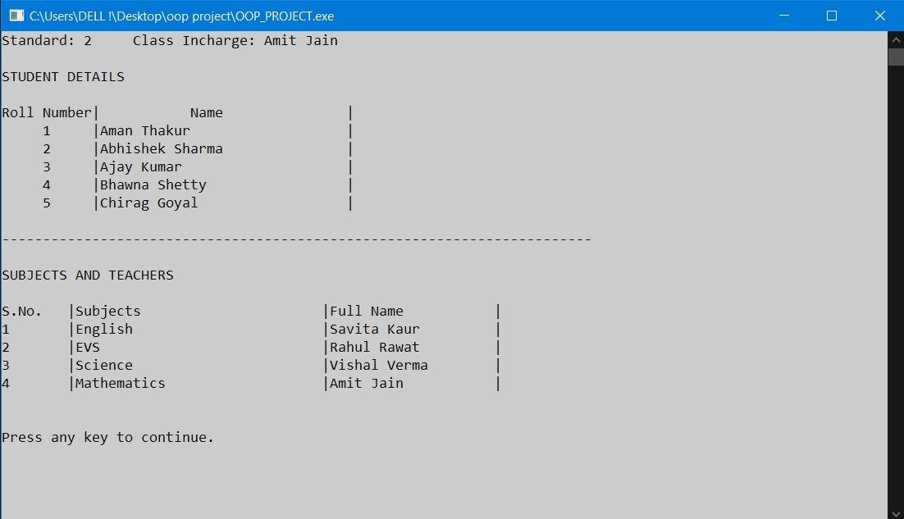

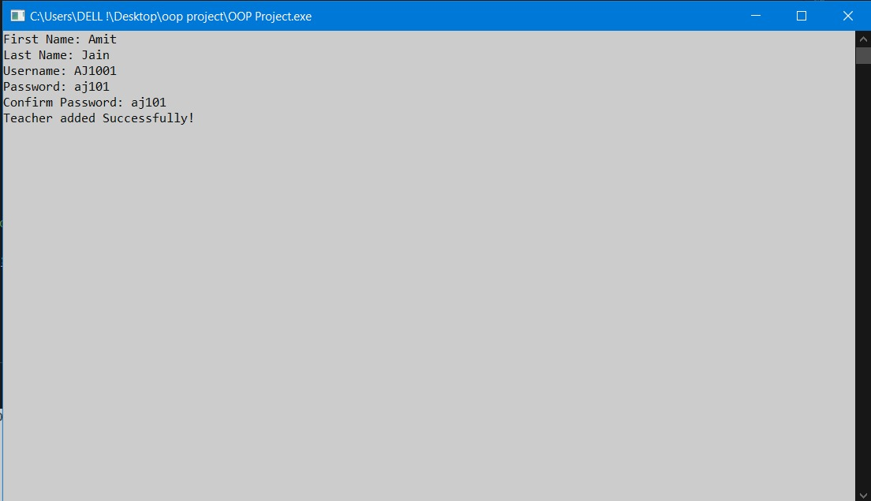

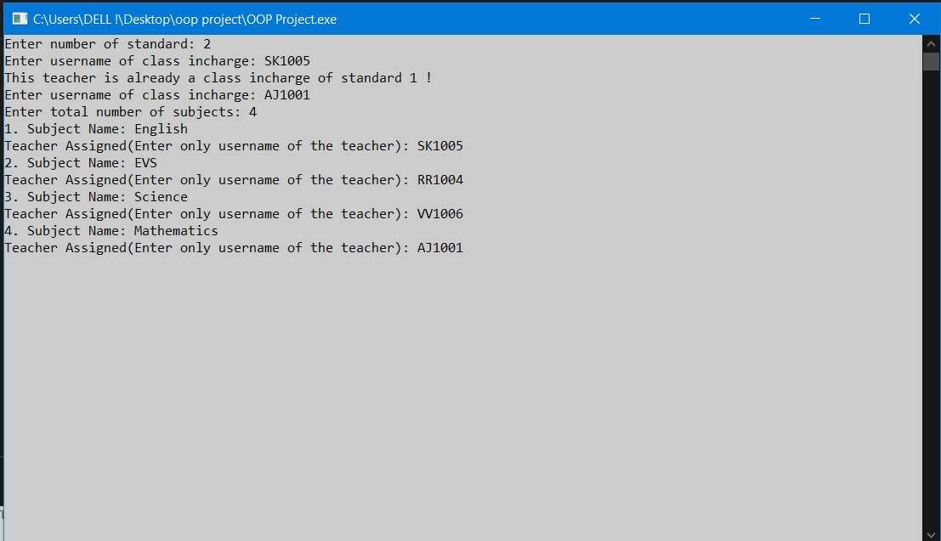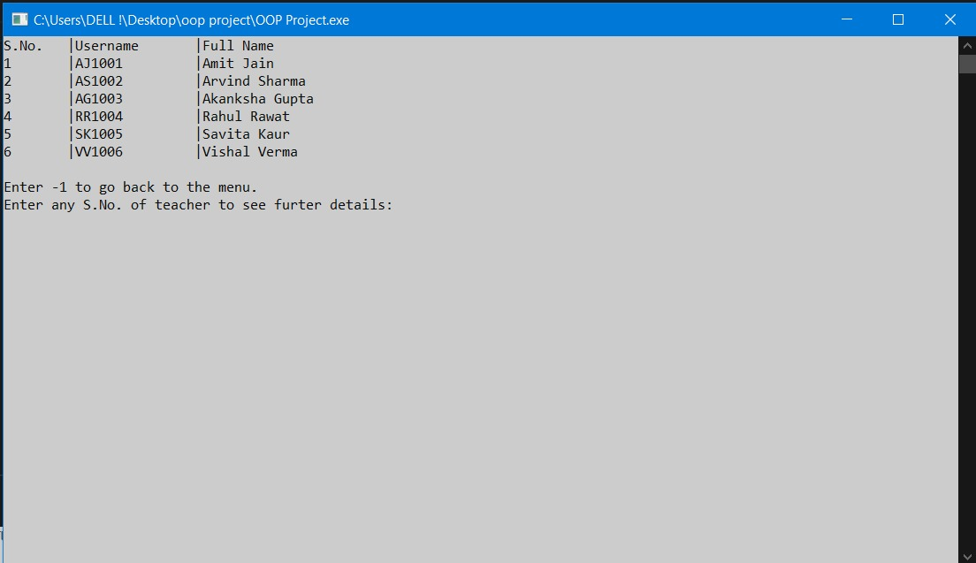

8.2 TEACHER MENU:

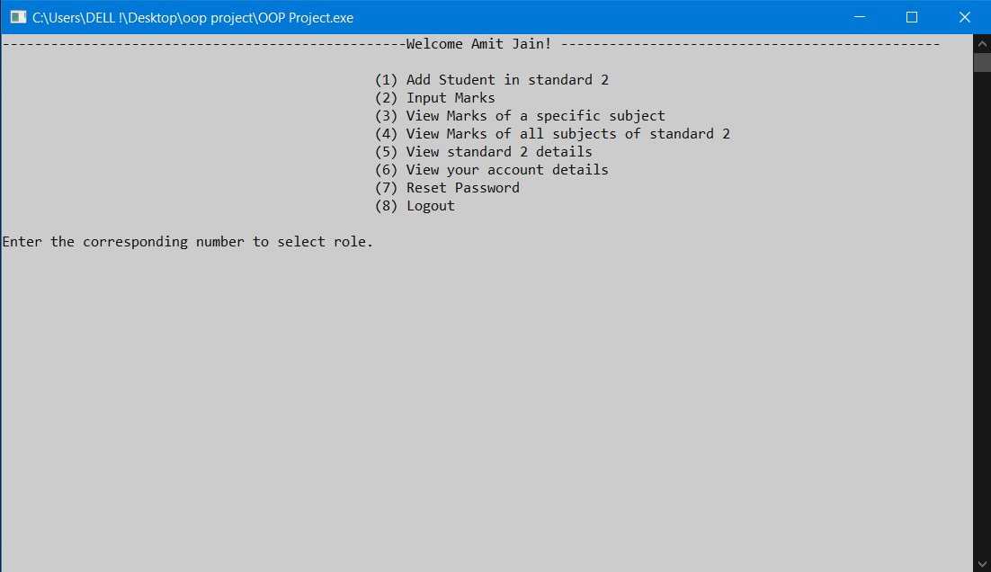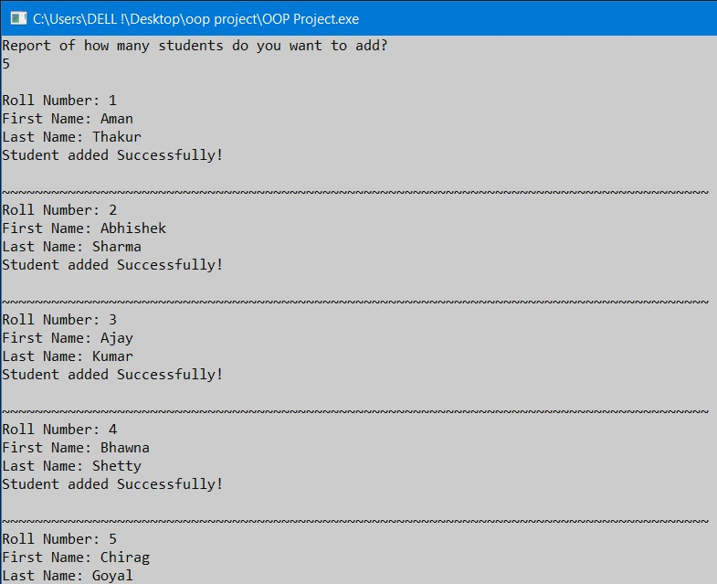

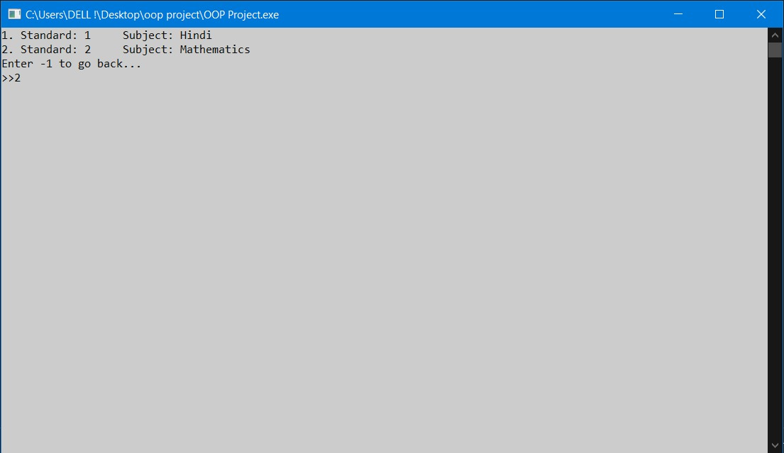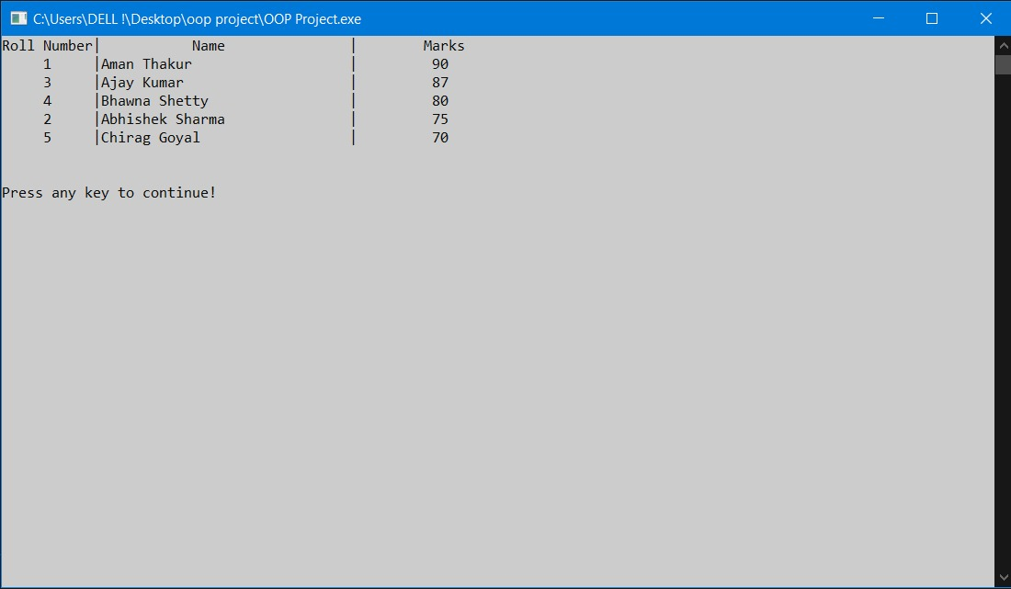

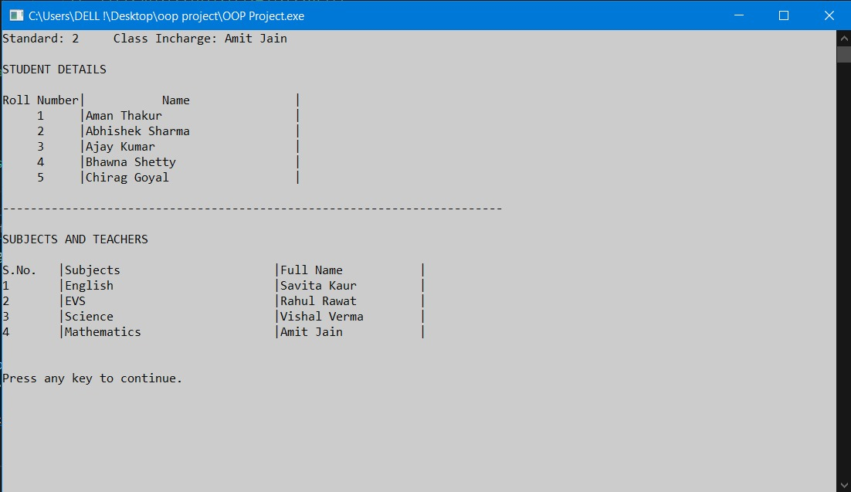

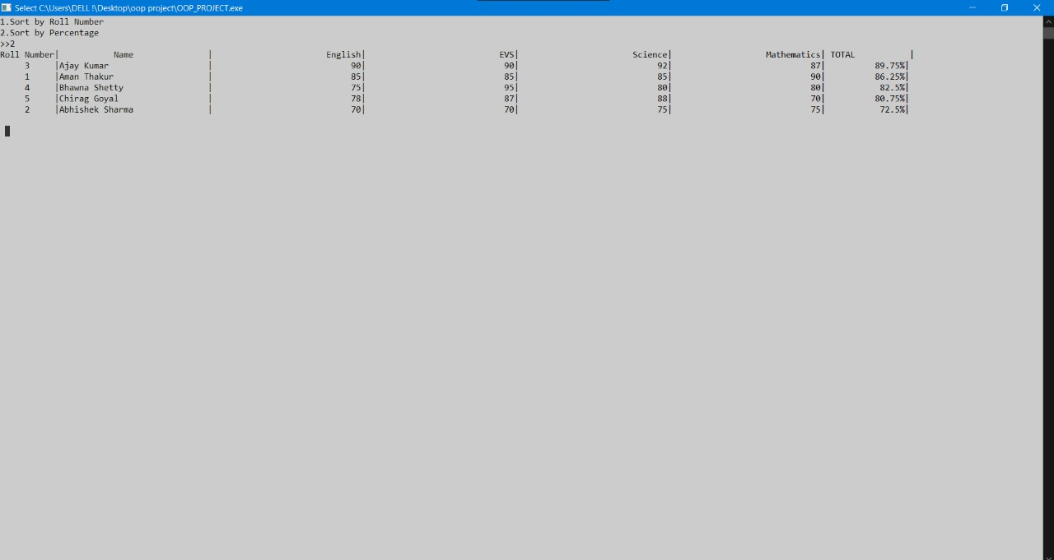

**9.CONCLUSION**

The result obtained is a basic, stable and user-friendly program that can store, access and modify student exam report.

**10.REFERENCES**

* [www.google.com](http://www.google.com/)
* Object Oriented Programming in C++ by E.Balaguruswamy
* [www.geeksforgeeks.com](http://www.geeksforgeeks.com/)
* <https://en.cppreference.com/w/>